EM304 – Integrated Design Project
Systems Engineering: Lifecycle Worksheet

In Lecture 2 we talked about system lifecycles and how the discipline of project management looks to apply lifecycle techniques to achieve something by a given time (whilst balancing quality and cost). We established that common understanding of the system’s lifecycle helps you plan what you should be doing at each stage. Teams which manage project progress ensure that all engineering goals in a phase are met before proceeding. Use the table below to develop a common plan within your group to understand your system lifecycle.
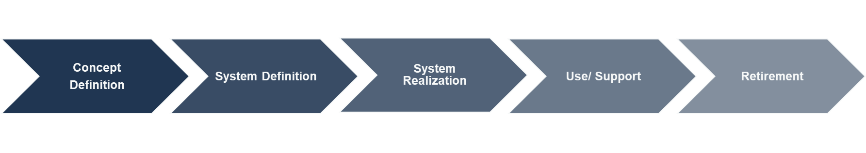
What engineering activities will you undertake during this phase? | Scale + Function | Input, output for each system and corresponding roles | Manufacturing of electrical + mechanical system, integrated testing | Full integrated test, and demonstration, fully functioning | Final maintenance
What do you need to do now to prepare for this phase? | Look at existing chargers | Understand the function of each system | Previous definitions and manufacturing planning | Completed testing, high degree of certainty of function | Ensure system is robust pre-demonstration
What information/ reports will you create during this phase? | Define the scale + function | List of components for each subsystem | Costs, assembly and testing plan | Post demonstration review | Recycling plan
How will you show that this phase is complete? (What is your stage gate?) | Everything defined and agreed upon | All systems & components defined | Fully assembled and tested system | Post demonstration | Once the project has been stored
What is the approximate timeline (in weeks) | ~ Week 5 S1 | ~ Week 11 S1 | ~ Week 6 S2 | ~ Week 11 S2 | ~ Exam period S2

